Supporting Young Carers in Education Settings
Recent national data and reports show that young carers remain at a significant disadvantage in education. This bulletin highlights key findings on attendance, suspensions/ exclusions, and Ofsted’s new inspection framework, with practical recommendations for school leaders.

Key insights on young carers
- Attendance: Young carers miss an average of 23 days per year (vs 14 for peers). Nearly half of secondary school age young carers (46%) are persistently absent. Caring responsibilities contribute to lateness.
- Suspensions & Exclusions: Young carers are more than twice as likely to be suspended (27 suspensions per 100 vs 11 for peers) and almost twice as likely to be permanently excluded. Rates are the highest in secondary schools.
- Wellbeing & School Experience: Almost half of young carers (48%) report being bullied; many struggle with homework and revision due to caring duties. One in four reports “no support at all” in their school.
- Attainment: Young carers are significantly less likely to achieve GCSE and A-Level benchmarks and to progress to higher education. An All-Party Parliamentary Review for Young Adult Carers’ access to Higher Education is in progress. The findings of the report were published and launched in Parliament on Monday 12th January.

Ofsted’s new inspection framework (from Nov 2025)
The new inspection framework and toolkit for education providers includes multiple references to young carers in both inclusion and attendance sections with the measures being expected as standar. This is included in toolkits for state-funded schools, academies, non-association independent schools, FE/Skills and initial teacher training.
- Inclusion is now a core evaluation area and a “golden thread” across inspections
- Inspectors will look at how schools identify and support vulnerable pupils, including young carers, in attendance, achievement, wellbeing and behaviour.
- Schools will need to evidence effective systems of identification of young carers, and how they adapt support to remove barriers to their attendance, achievement, and wellbeing.

School Census – Top Tips for Recording Young Carers
Schools in England are required to report on the number of young carers in their January school census return each year.

- Accurately Code
Schools will be asked to record the information using the following codes.
Note, the default value will be ‘N’, not declared. This is not a mandatory field, and it is possible to move to the next stage of the census without completing this field.

Code | Young Carer indicator
N | Not declared
P | Identified as a young carer by parent or guardian
S | Identified as a young carer by school

For young carers identified by the school (e.g. a young carer self-identified on the back of an assembly, tutor time or pastoral support), use the ‘S’ code, identified as a young carer by school. For a young carer identified by the parents/carers or local young carers service, use code ‘P’, identified by parent/guardian.
Note, an education setting does not need a Young Carers Service to confirm whether a young person is a young carer. This may result in some young carers not being identified should there be barriers to accessing an external support service.
- Ensure Accurate Information
Research tells us that there are on average two young carers in every classroom. However, in 2025, nationally, 69% of schools reported they have no young carers in their school.
It is clear that not all school systems have a method for identifying a pupil as a young carer. It is important that those that know who their young carers are (trained Designated leads for Young Carers, DSLs, pastoral staff) pass this information on to those who populate the data in the school census.
- Identify & Support
Once you have an accurate understanding of which pupils are juggling caring responsibilities alongside their education, seek to find ways to support them with this balance (flexible homework, attendance support, pastoral care).

Recommendations for education providers – see appendix for resources
To prepare for inspection and improve outcomes for young carers:

- Appoint a Young Carer Lead/Champion – ensure all staff and pupils know who this is.
- Adopt a Young Carers Policy – set out clear support (flexibility with homework, access to opportunities).
- Improve Identification & Recording – actively capture young carers on enrolment and census returns; ensure accurate reporting.
- Strengthen Support – provide pastoral support, access to phones, young carer groups, and mental health/wellbeing provision.
Always ‘Think Family’ - Young carers do not provide care in isolation. Although they may require support themselves, their needs must be considered and met in the context of their whole family. Understanding the cared for person’s needs is integral to making a long-term sustainable difference to improve the quality of life for the whole family.
- Evidence Impact – keep records of interventions, attendance data, and pupil voice to show inspectors.
- Raise Awareness – young carer notice boards, train staff and pupils/families to understand young carers’ challenges; reduce stigma and improve peer awareness.

Key message for education providers
Young carers are at higher risk of absence, suspension, and exclusion, yet often remain hidden. With Ofsted now scrutinising inclusion more closely, schools must demonstrate robust identification and support. Proactive action will not only improve inspection outcomes but, crucially, will help close the education gap for young carers.

Service Contact Details
Sophie Parker, Young Carers Service Manager sophie.parker@family-action.org.uk
Contact the team for staff training and awareness sessions at youngcarersrotherham@family-action.org.uk or visit our website Young Carers Rotherham - Family Action
References
All Party Parliamentary Group (Nov 2023) Inquiry into the life opportunities of young carers and young adult carers. Carers Trust (2024) Caring and classes: the education gap for young carers. Carers Trust (July 2025) Young Carers and suspensions/exclusions from school. Gov UK (Sept 2025) Education inspection framework: for use from November 2025. Young Carers in Schools Young Carers and the School Census
Appendix
- Referral guidance Rotherham Young Carers Support Service is commissioned to work with families where a child or young person is providing high levels (excessive) and/or age-inappropriate care to a family member. This does not mean that young carers that are not as significantly impacted or not providing high levels of care should go unsupported. Depending on the family's support needs additional help can be sourced through universal and targeted services e.g. Family Hubs.
- Manual for Measures of Caring Activities and Outcomes for Children and Young People - Resources - Carers Trust this tool can be used with children, young people and families to help better understand what care a child is providing, how much and the impact it is having. This can help understand what support may be required.
- Template wording for mental health service referral forms – routine questioning on referral forms and during assessment can provide a safe space to explore with an adult their care needs, who supports them and how.
- Emergency plan – can support families to consider different scenario’s and help keep the cared for adult and children in the home safe.
- Young Carers Alliance Resources - Carers Trust – consider books, resources and information that support a young carer to better understand their situation. Health specific information can also be very helpful to help a young carer understand more about their family members health condition reducing fear/anxiety and ensuring the cared for person’s and young carers safety.
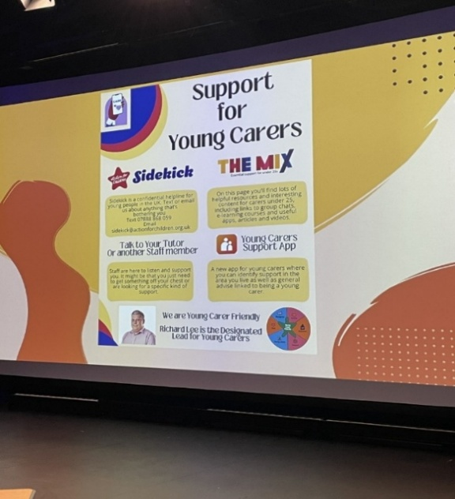
- Create a Young Carers Notice board – Include who staff/service users can go to within the setting if they need to talk or get support as well as showcase the settings commitment to supporting young carers and their families. We have developed a Young Carers Support Service, Rotherham poster and Young Carers Support Service, Rotherham leaflet that can be used as part of the display
