Identifying and Supporting Young Carers in Adult Settings
Recent national data and reports show that young carers remain at a significant disadvantage in many areas of their lives.

Key insights on young carers
- Wellbeing: Young carers in the UK (under 18) and young adult carers (16-25) face significant mental health and wellbeing challenges, with around 44% reporting constant stress and many experiencing loneliness, anxiety, and exhaustion due to care responsibilities
- School Attendance: Young carers miss an average of 23 days per year (vs 14 for peers). Nearly half of secondary school age young carers (46%) are persistently absent. Caring responsibilities contribute to lateness.
- Aspirations: Young carers are significantly less likely to achieve GCSE and A-Level benchmarks and to progress to higher education. 35% lower chance of achieving 5+ GCSEs and they are 38% less likely to obtain a university degree.

CQC inspection framework
CQC guidance, aligned with the Care Act 2014, requires adult social care providers to adopt a "whole-family approach," ensuring young carers (under 18) and young adult carers (18-25) are identified, assessed, and supported to reduce inappropriate care roles.
Key CQC guidance and statutory duties for young carers:
- Identification & Assessment: Local authorities must identify young carers and provide a needs assessment that considers the impact of caring, regardless of the type of care provided.
- Whole-Family Approach: Adult social care services must not just focus on the adult receiving care. They should also identify young people in the household providing care.
- "No Wrong Doors" Initiative: The Carers Trust "No Wrong Doors" MoU encourages a system where any service (health or social care) can help a young carer access support.
- Transitions to Adulthood: As young carers turn 18, they are entitled to a Transitions Assessment to plan for adult care and support needs.
- Safeguarding: Concerns about a young carer’s wellbeing must be addressed immediately via local safeguarding, particularly if the care role is inappropriate.
- CQC Assurance: The CQC monitors how local systems (including Adult Social Care) and partners work together to identify and support young carers
Recommendations for Adult settings – see appendix for resources
To prepare for inspection and improve outcomes for young carers:
- Appoint a Young Carer Lead/Champion – ensure all staff and service users know who this is.
- Adopt a Young Carers Policy – set out clear support (roles and responsibilities of staff, offers of support to adults with care needs and their children)
- Improve Identification & Recording – actively capture young carers on data management systems; ensure accurate reporting and evidence impact.
- Raise Awareness – young carer notice board, train staff and service users /families to understand young carers’ challenges; reduce stigma and improve peer awareness.
Top Tips for identifying and supporting young carers.
- Ask Directly but Sensitively: When assessing an adult, explicitly ask if any children or young people in the household help with care tasks – considering emotional care as well as practical care.
- Use Specific Questions: Ask "Do you ever need help with [bathing/dressing/medication/cooking]?" rather than just "Do you have a carer?".
- Implement a Whole Family Approach: Always ‘Think Family’ - Young carers do not care in isolation. Although they may require support themselves, their needs must be considered and met in the context of their whole family. Understanding the cared for person’s need is integral to making a long-term sustainable difference to improve the quality of life for the whole family.
- Minimize Care Responsibilities: Actively seek to replace the young person's care with professional, paid care services and/or other adults in the family/friend network.
- Create Emergency Plans: Develop contingency plans with the adult, ensuring the young person is not left providing high amounts and/or age-inappropriate care.

Service Contact Details
Sophie Parker, Young Carers Service Manager sophie.parker@family-action.org.uk
Contact the team for staff training and awareness sessions at youngcarersrotherham@family-action.org.uk or visit our website Young Carers Rotherham - Family Action
References
All Party Parliamentary Group (Nov 2023) Inquiry into the life opportunities of young carers and young adult carers. Carers Trust (2024) Caring and classes: the education gap for young carers. Carers Trust (July 2025) Young Carers and suspensions/exclusions from school. Gov UK (Sept 2025) Education inspection framework: for use from November 2025. Young Carers in Schools Young Carers and the School Census
Appendix
- Referral guidance Rotherham Young Carers Support Service is commissioned to work with families where a child or young person is providing high levels (excessive) and/or age-inappropriate care to a family member. This does not mean that young carers that are not as significantly impacted or not providing high levels of care should go unsupported. Depending on the family's support needs additional help can be sourced through universal and targeted services e.g. Family Hubs.
- Manual for Measures of Caring Activities and Outcomes for Children and Young People - Resources - Carers Trust this tool can be used with children, young people and families to help better understand what care a child is providing, how much and the impact it is having. This can help understand what support may be required.
- Template wording for mental health service referral forms – routine questioning on referral forms and during assessment can provide a safe space to explore with an adult their care needs, who supports them and how.
- Emergency plan – can support families to consider different scenario’s and help keep the cared for adult and children in the home safe.
- Young Carers Alliance Resources - Carers Trust – consider books, resources and information that support a young carer to better understand their situation. Health specific information can also be very helpful to help a young carer understand more about their family members health condition reducing fear/anxiety and ensuring the cared for person’s and young carers safety.
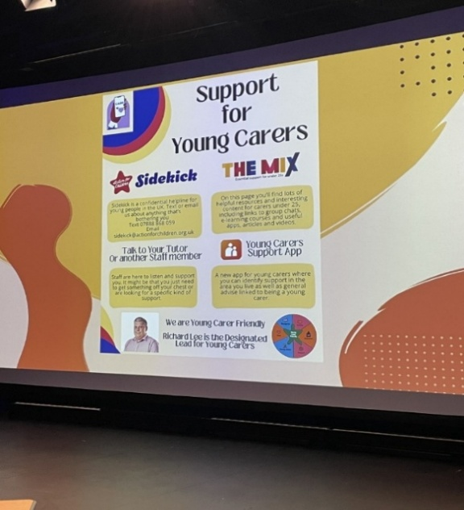
- Create a Young Carers Notice board – Include who staff/service users can go to within the setting if they need to talk or get support as well as showcase the settings commitment to supporting young carers and their families. We have developed a Young Carers Support Service, Rotherham poster and Young Carers Support Service, Rotherham leaflet that can be used as part of the display
