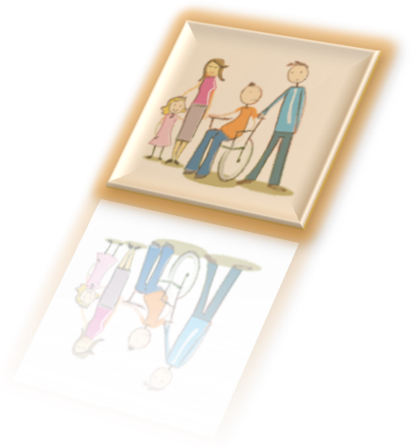




Walsall’s Targeted School Holiday Activities
Short Breaks can benefit the whole family. They provide opportunities for children and young people with a disability to spend time away from their families, relax, develop new friendships, take part in new experiences, and have fun doing positive activities. They also give families a break from their caring responsibilities, a chance to rest or spend time with their other children.

We recognise that all families are different and will need different levels of support and different types of Short Breaks; therefore, we ensure that there is a wide range of Short Breaks to meet those needs.

Short breaks are part of the support for an ‘Ordinary Life’ as set out in the Children and Families Act 2014. We want young people to be healthy, safe, achieve, make a positive contribution, have supportive friends and families and benefit from economic well-being.

Eligibility
To access targeted School Holiday activities, children and young people should:

- be aged from 8 to 17 years old (up to their 18th birthday)
- live in Walsall
- have a diagnosed disability and
- be in receipt of disability living allowance (DLA)
- An up-to-date short breaks passport (reviewed and updated within the last 12 months) is required to access the service, to ensure we have the right information for the planning of activities and support for our children and young people

The Short Break booklet and expression of interest online form for school holiday activity schemes for every holiday (excluding Christmas) is available six weeks before each school holiday via the local offer: https://go.walsall.gov.uk/the-send-local-offer/Social-Care/ShortBreaks#148001731-targeted-short-breaks.
To join the mailing list for 2023 and receive the booklet by email, families can opt in by emailing shortbreaks@walsall.gov.uk.

For Further Information on Walsall’s Short Break Services Please contact: Liz Phillips. Short Breaks and Inclusion Co-ordinator: Phone: 07743 559783 or E mail: Shortbreaks@walsall.gov.uk



