**Summer Newsletter**

Welcome to our Summer Newsletter which will give you details of all our services that we are providing between July & September.

We would like to welcome and thank all the new families who have registered with us over the past few months and say a warm hello to those who have joined us already.

We look forward to continuing to deliver our services to you all.

**For further details of our Summer activities**

**please contact any of our centres:**

**Cockermouth**, South Street, CA13 9RT, 01900 810869

**Flimby**, Sand Lane, CA15 8QS, 01900 810869

**Keswick**, Trinity Way, CA12 4HZ, 01900 604822

**Maryport**, Ennerdale Road, CA15 8HN 01900 810869

**Silloth**, Liddel Street, CA7 4DD, 016973 43870

**Wigton**, 10—12 Wampool Place, CA7 9SA, 016973 43870

**Workington**, Nilsson Drive, CA14 5BD, 01900 604822

Or call our single point of access number on **07815687287**

**Visit our website at** [**https://www.family-action.org.uk/**](https://www.family-action.org.uk/)**cumbria**

**or check out our Facebook page at: Facebook.com/AllerdaleSupport**

SUMMER FAMILY FUN

On the Beach!



[This Photo](https://freepngimg.com/png/24396-sail-hd) by Unknown Author is licensed under [CC BY-NC](https://creativecommons.org/licenses/by-nc/3.0/)



**Spaces still available at:**

**Silloth - Thursday 1st August 10.00am – 11.30am**

North Allerdale Children’s Centre, Liddell Street, Silloth, CA7 4DR

**Flimby - Wednesday 14th August 10.00am – 11.30am**

West Allerdale Children’s Centre, Sand Lane, Flimby, CA15 8QS

For further information or to book you place, please contact: **07815687287**

Or by email at **Allerdale@family-action.org.uk**

Join us this summer for an afternoon of fun free activities.

Face Painting

Arts & Crafts

Pebble painting

Messy Play

Outdoor Activities

and more

**SUMMER FAMILY FUN**

**All the Fun of the Fayre**

Join us this summer for an afternoon of fun free activities.

Face Painting

Hook a Duck

Treasure Hunt

Messy Play

Tin Can Alley

and more



**Cockermouth - Monday 5th August 1.00pm – 2.30pm**

**West Allerdale Children’s Centre, 2 The Dairy, South St, Cockermouth CA13 9RT**

**Keswick - Wednesday 21st August 10.00am -11.30am**

**Derwent Valley Children’s Centre, Trinity Way, Keswick, Cumbria, CA12 4HZ**

**Wigton - Friday 23rd August 10.00am-11.30am**

**North Allerdale Children’s Centre, 10-12 Wampool Pl, Wigton CA7 9SA**

For further information or to book you place, please contact: **07815687287**

Or by email at **Allerdale@family-action.org.uk**

**Universal Sessions**

Stay & Play, Baby Explorers & our Breast feeding Support group will be finishing for the Summer Holiday’s. Thank you to everyone who have attended the sessions during April- July, please look out for our dates when we will be starting the groups in September. We hope you all have a lovely summer.

Your feedback matters! If you have attended any of our universal sessions between April & July please scan the QR code below.

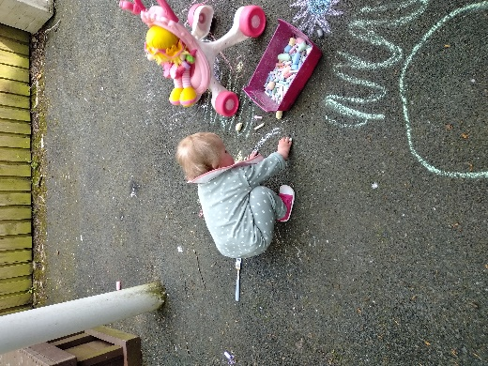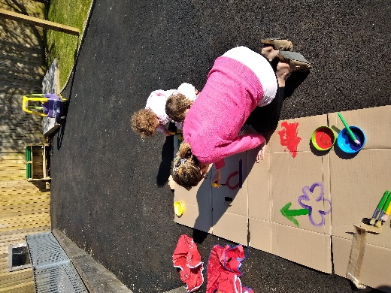

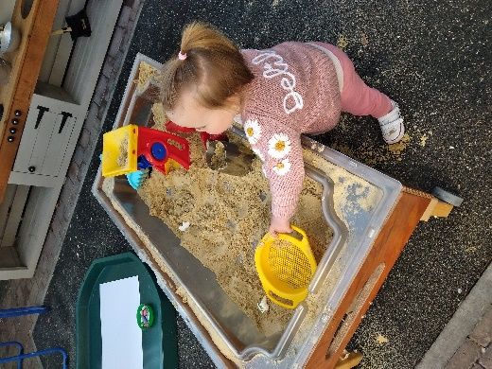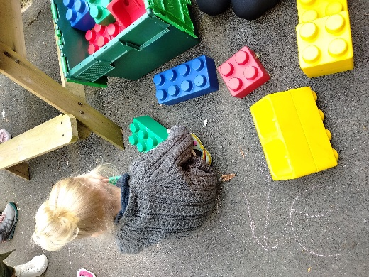

**Services for Parents/Carers**

**Solihull Online Course**

The Solihull programme will help you understand your child’s development and behaviour and promotes positive emotional health and wellbeing. This online course can be completed in your own time, and there are courses suitable from pregnancy to 19 years and translated in a wide range of languages.

**To access this, visit** [**www.inourplace.co.uk**](https://gbr01.safelinks.protection.outlook.com/?url=http%3A%2F%2Fwww.inourplace.co.uk%2F&data=05%7C01%7Cabigail.thomason%40family-action.org.uk%7C3f2ddbb9f5bb4673aa5208dbe9c264e8%7C7c3c6b24370f462392f2ecf5e01521ac%7C0%7C0%7C638360793474782793%7CUnknown%7CTWFpbGZsb3d8eyJWIjoiMC4wLjAwMDAiLCJQIjoiV2luMzIiLCJBTiI6Ik1haWwiLCJXVCI6Mn0%3D%7C3000%7C%7C%7C&sdata=Gen9wC1bTjPFlpqhcFBe0qYxJnUkYqeW6HEy8VhdC8M%3D&reserved=0) **and use the code** **WORDSWORTH**

**Strengthening Families**

Are you unsure if you are receiving the correct benefits?

If you would like more advice and guidance around what you may or may not be entitled too, why not come along to one of our Drop-In sessions. We have friendly advisors available to give you advice on benefit checks, benefit advice, breakdown of individual entitlements, getting back into work & the benefits of working and better off calculations.

**To register your interest or to book an appointment please contact Michaela on:**

**07815686874** or email **michaela.walker@family-action.org.uk**

**Sensory Rooms**

We have Sensory Rooms in our Children’s Centres in Keswick and Workington. These are bookable for families of children with an additional need aged between 0 - 6 years. The rooms have a range of sensory equipment to support your child with their learning and development in a safe and comfortable environment. A member of staff will be on hand at all times to support you with using the equipment and to answer any queries that you may have.

**Workington Children Centre:**

Mondays from 9:30am - 4:00pm

Wednesdays from 9:30am - 4:30pm

**Keswick Children’s Centre:**

Tuesdays from 9:30am - 4:00pm

Fridays from 9:30am - 4:00pm

**For further information please contact us on 07815687287**

**Or by email at Allerdale@family-action.org.uk and someone will contact you with**

**further information**

**Smile 4 Life**

Do you want more information about the best way to help keep your family’s teeth and mouth healthy?

We can support you with lots of interesting and useful tips that you can put into place to encourage and promote good oral health for you and your children from an early age. We can also provide information on getting registered with a dentist and answer any questions that you may have.

**For further information please contact us on 07815687287**

**Or by email at Allerdale@family-action.org.uk and someone will contact you**

**Volunteering**

**Could you be a Volunteer with us?**

Volunteering has been at the heart of Family Action since we were established in 1869, run solely by volunteers. As a volunteer you will gain valuable skills and experience working as part of a team making a real difference to the lives of children, young people and families in your area and there are lots of ways you can give your time.

**If this interests you or you would like an informal chat please contact:**

Michaela Walker on **michaela.walker@family-action.or.uk** or call **07815686874**

**Perinatal Peer Support Service**

**Perinatal Peer Support Volunteer**

Do you have what it takes to provide emotional support to a mum or primary care giver during the perinatal period. The Perinatal period is during pregnancy and a year following the birth.

We are looking for volunteers to support parents who are experiencing a mild to moderate mental health illness or are identified as vulnerable to developing a mental health illness during the perinatal period. This support may be offered through home visits, remote telephone or video call, group work or support to access other local services.

It is preferable if you have experienced pregnancy and childbirth, or you have an understanding of mental distress, the emotional effects of pregnancy and birth and the demands of parenthood

**For further information please contact us on 07815687287**

**or by email at Allerdale@family-action.org.uk and someone will contact you for further information**



**FamilyLine**

Family pressures can sometimes be difficult to manage without emotional support and guidance to help. Many people feel confused by what information is available or struggle to access services close to home.

Our free FamilyLine service, tackles these issues in a new and innovative way by using a network of [volunteers](https://www.family-action.org.uk/get-involved/volunteer/) from across the country to support family members over the age of 18 through telephone calls, email, web chat and text message.

The service aims to:

* provide both immediate and long-term support
* help with practical information and guidance
* provide emotional and listening support
* help with understanding and accessing relevant services and information
* provide regular one-to-one befriending support to service users feeling isolated
* access to short term telephone counselling
* a referral into our many projects across England and Wales, where relevant.

**Please contact us for support in the following ways Monday to Friday 9:00am – 9:00pm**

**call**: 0808 802 6666,

**text**: 07537 404282,

**email**: [familyline@family-action.org.uk](mailto:familyline@family-action.org.uk) or live web via our website [www.family-action.org.uk](http://www.family-action.org.uk)

**Contacting us out of hours:**

Do you need FamilyLine but it’s out of our operation hours? You can either call back in our opening hours, leave a message on our voice mail for a call back in our operation hours or if you’re in crisis you can contact our crisis line to get in touch with a trained professional.

* Text FAMILYACTION to 85258

Our crisis messenger text service provides free, 24/7 crisis support across the UK. We know that getting the correct support at the right time is so beneficial which is why we’ve introduced our crisis line. This service is delivered in partnership with [Shout](https://www.crisistextline.uk/).



**Other agencies that may help you**

**CADAS** provides confidential quality support, training and 1-1 counselling sessions for those interested in and/or affected by the use of Alcohol and Drugs. <https://cadas.co.uk/> 03001114002

**Child Bereavement UK** gives support about grieving and loss <https://www.childbereavementuk.org/>

**Childline** will provide advice and support for young people.<https://www.childline.org.uk/>

**Citizens Advice** is an independent charity set up to provide free, impartial and confidential advice on almost any subject <https://www.citizensadviceallerdale.org.uk> 01900 604735

**E-School Nurse Video Clinics** are held twice a week providing online health support and advice for parents, carers and professionals supporting children aged 5-19. <https://cumbria.gov.uk/ph5to19/priorities.asp> or 0300 30 34 365

**Every Life Matters** is a**Cumbrian suicide prevention and suicide bereavement support charity.** <https://www.every-life-matters.org.uk/>

**Mind** offers support with mental health. <https://cemind.org/>or 0300 123 3393

**North Lakes Foodbank** 07502311452 or via email info@thefoodbank.org.uk

**Young Minds** offers support for young people with their mental health. <https://youngminds.org.uk/> or text YM to **85258** if you need urgent help

**Scan this code for direct access to our facebook page!**

